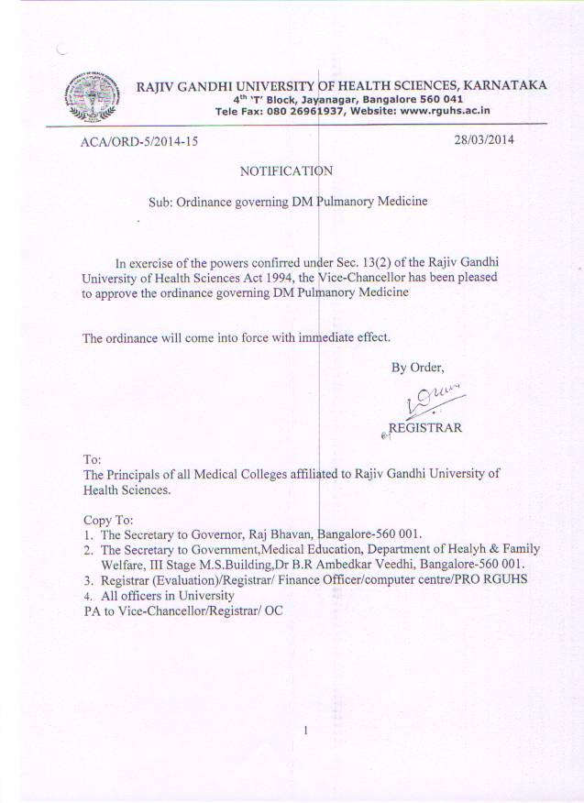

DM curriculum in “Pulmonary Medicine”

Goal

On completing his training the DM resident should be a competent specialist in pulmonary medicine capable of assuming a consultants role in the sub specialty. He/she must acquire a working knowledge of the sub specialty including its foundations in the basic sciences and research that will help him/her towards achieving this objective. He/she should be an accomplished professional who practices responsibly while caring for other. He/she should be able to teach and train students in the sub specialty.

Qualifying requisites

Training in internal medicine (or Chest Diseases) with an MD or DNB.

Duration

Three years of which
- 28 months in pulmonary medicine
  - 18 months pulmonary medicine (Wards, out-patients, clinics, US, FOB & consultation)
  - 4 months sleep medicine.
  - 2 months pulmonary function laboratory.
- 6 months critical care
- 2 months cardiology & cardiothoracic surgery.

Curriculum

2.1.1. Basic sciences
2.1.1.1. Embryologic development of the respiratory system and how congenital anomalies arise
2.1.1.2. Basic principles of clinical genetics relevant to the respiratory system and diseases of the respiratory system
2.1.1.3. Gross and microscopic anatomy of the lungs, pulmonary vasculature, chest wall, and neuromuscular apparatus and the basic anatomy of the upper airway and brainstem
2.1.1.4. Respiratory physiology:
2.1.1.4.1. Alveolar gas composition
2.1.1.4.2. Ventilation and its control
2.1.1.4.3. Distribution of alveolar ventilation
2.1.1.4.4. Diffusion
2.1.1.4.5. Perfusion and vascular physiology
2.1.1.4.6. Ventilation perfusion relationships
2.1.1.4.7. Oxygen delivery, utilization, and transport
2.1.1.4.8. Carbon dioxide transport
2.1.1.4.9. Acid base balance
2.1.1.410. Mechanics of breathing
2.1.1.4.11. Respiratory muscle function
2.1.1.4.12. Respiratory system in sleep
2.1.1.4.13. Respiratory system during exercise
2.1.1.5. Basic principles of clinical immunology as they apply to respirology
2.1.1.6. Basic principles of molecular biology relevant to respirology
2.1.1.7. Mechanisms of action of major pharmacological agents with effects on the respiratory system
2.1.1.8. Broad knowledge of microbiology as it relates to respirology, including normal defense mechanisms
2.1.1.9. Fundamental principles of epidemiology
2.1.1.10. Cardiovascular physiology as it applies to respirology and cardiopulmonary interaction as seen in various respiratory disorders
2.1.1.11. Basic gross and microscopic pathology as applied to clinical disorders of respiratory system

2.1.2. Clinical sciences
2.1.2.1. Pathophysiology, clinical manifestations, differential diagnosis, general approach to prevention, diagnosis and management , natural history and prognosis of the following.
2.1.2.1.1. Signs and symptoms: dyspnea, cough, snoring, hemoptysis, chest pain, cyanosis, adventitious sounds, clubbing
2.1.2.1.2. Abnormalities of developmental origin or disease arising from prematurity that may have continuing impact in adult life
2.1.2.2. Airway disease:
2.1.2.2.1. Upper airway, including:
2.1.2.2.1.1. Epiglotitis
2.1.2.2.1.2. Laryngotracheobronchitis
2.1.2.2.1.3. Tracheitis
2.1.2.2.1.4. Foreign bodies
2.1.2.2.2. Lower airway, including:
2.1.2.2.2.1. Asthma
2.1.2.2.2.2. Chronic obstructive pulmonary disease (Chrobronchitis, emphysema)
2.1.2.2.2.3. Bullous disease
2.1.2.2.2.4. Bronchiectasis
2.1.2.2.2.5. Cystic fibrosis
2.1.2.2.2.6 Bronchiolitis
2.1.2.2.2.7. Dysmotility syndromes
2.1.2.4. Pleural disorders:
2.1.2.4.1 Pleural effusions, pneumothorax, pleural plaques and thickening, mesothelioma and other malignancies
2.1.2.5. Mediastinum:
2.1.2.5.1. Mediastinitis, pneumomediastinum, mediastinal masses, vascular abnormalities
2.1.2.6. Neoplastic disorders:
2.1.2.6.1. Benign
2.1.2.6.2. Malignant (primary and secondary)
2.1.2.6.3. Paraneoplastic syndromes
2.1.2.7. Infectious diseases:
2.1.2.7.1. Infections of upper and lower respiratory tract
2.1.2.7.2. Infections in the normal host (community acquired and nosocomial) and in the immunocompromised host
2.1.2.7.3 Infections caused by bacteria, viruses, mycoplasma, Chlamydia, rickettsias, fungi, protozoons, metazoons, mycobacteria
2.1.2.8. Industrial and environmental disease:
2.1.2.8.1 Inorganic and organic pneumoconiosis
2.1.2.8.2. Air pollution, sick building syndrome, and smoking
2.1.2.8.3. Occupational asthma, reactive airways dysfunction syndrome
2.1.2.9. Complications of aspiration of:
2.1.2.9.1. Gastric contents
2.1.2.9.2. Foreign bodies
2.1.2.9.3. Lipoid material
2.1.2.9.4. Water, including immersion injuries
2.1.2.10. Immunologic diseases:
2.1.2.10.1. Rhinitis
2.1.2.10.2. Asthma
2.1.2.10.3. Extrinsic allergic alveolitis
2.1.2.10.4. Eosinophilic lung disease
2.1.2.10.5. Respiratory manifestations of collagen vascular disease
2.1.2.10.6. Pulmonary vasculitis
2.1.2.10.7. Bronchiolitis obliterans organizing pneumonia
2.1.2.11. Lung injury:
2.1.2.11.1. Trauma
2.1.2.11.2. Drugs (including recreational and illicit drugs)
2.1.2.11.3. Radiation
2.1.2.11.4. Oxygen
2.1.2.11.5. Thermal
2.1.2.11.6. Barotrauma
2.1.2.12. Restrictive diseases:
2.1.2.12.1. Chest wall deformities
2.1.2.12.2. Neuromuscular diseases
2.1.2.12.3. Interstitial lung diseases
2.1.2.12.4. Pleural disorders
2.1.2.13. Pulmonary hemorrhage syndromes
2.1.2.14. Disorders of the pulmonary circulation:
2.1.14.1. Pulmonary embolism (thrombo-embolism, fat, air, tumor, amniotic fluid)
2.1.2.14.2. Pulmonary hypertension
2.1.2.14.3. Pulmonary edema
2.1.2.14.4. Cor pulmonale
2.1.2.14.5. Pulmonary arteriovenous malformations, fistulas and other vascular abnormalities.
2.1.2.15. Non cardiogenic pulmonary edema
2.1.2.16. Sleep disorders:
2.1.2.16.1. Excessive daytime somnolence
2.1.2.16.2. Sleep disordered breathing
2.1.2.16.3.Hypoventilation syndromes
2.1.2.16.4. Nonrespiratory sleep disorders (restless legs syndrome, periodic limb movement disorder, narcolepsy, parasomnias insomnia)
2.1.2.17. Respiratory manifestations of extra pulmonary disorders
2.1.2.18. Respiratory complications of pregnancy
2.2. Demonstrate an understanding of indications, benefit, contraindications, complications and general techniques of the following therapeutic / diagnostic interventions:
2.2.1. Pulmonary rehabilitation
2.2.2. Radiation therapy
2.2.3. Chemotherapy
2.2.4. Respiratory therapy
2.2.5. Physical therapy
2.2.6. Interventional bronchoscopy including endobronchial ultrasound (EBUS) and airway stenting.
2.2.7. Common surgical interventions:
2.2.7.1. Mediastinoscopy
2.2.7.2. Thoracotomy and lung resection
2.2.7.3. Thoracoscopy
2.2.7.4. Surgical management of empyema
2.2.7.5. Lung reduction surgery
2.2.7.6. Lung transplantation
2.2.8 Palliative care
2.2.9. End of life decision making

3. Perform a complete and appropriate assessment of a patient
3.1 Indentify and explore issues to be addressed in a patient encounter effectively, including the patient’s context and preferences
3.2. Elicit a history that is relevant, concise and accurate to context and preferences for the purposes of prevention and health promotion, diagnosis and / or management.
3.3. Perform a focused physical examination that is relevant and accurate for the purposes of prevention and health promotion, diagnosis and/ or management
3.4 Select medically appropriate investigative methods in a resource – effective and ethical manner.
3.5. Demonstrate effective clinical problem solving and judgment to address patient problems, including interpreting available date and integrating information to generate differential diagnoses and management plans.
3.5.1. Demonstrate proficiency in interpretation of chest radiographs
3.5.2. Recognize common abnormalities on chest computerized axial tomography (CT )scan
3.5.3. Demonstrate proficiency in interpretation of pleural fluid analysis
3.5.4. Demonstrate proficiency in the interpretation of common pulmonary function tests and cardiopulmonary exercise testing; understand the indications, technical aspects and quality assurance issues of such tests.
3.5.5. Demonstrate proficiency in the interpretation of blood gases
3.5.6. Identify common abnormalities and understand basic technical aspects of polysomnography.

- Demonstrate proficiency in the performance and use of:
4.1. Spirometry
4.2. Oxygen delivery systems
4.3. Inhalational devices

- Demonstrate proficient and appropriate use of procedural skills, both diagnostic and therapeutic
5.1. Perform indications, contraindications, technical aspects and quality assurance issues, and potential complications of the following.
5.1.1. Endotracheal intubation (oro and nasotracheal) with and without the use of bronchoscope
5.1.2. Initiation, maintenance and discontinuation of acute and chronic mechanical ventilation (including non- invasive techniques)
5.1.3. Bronchoscopy (including transbronchial biopsy, endobronchial biopsies, bronchoalveolar lavage and bronchoscopic fine needle aspiration)
5.1.4. Thoracentesis with or without ultrasound guidance
5.1.5. Pleurodesis
5.1.6. Placement of closed intrapleural chest tube
5.1.7. Arterial puncture and cannulation
5.1.8. Venous cannulation for placement of central venous and pulmonary artery catheters
5.1.9. Testing for latent tuberculosis
5.1.10. Ensure appropriate informed consent is obtained for procedures
5.1.11. Document and disseminate information related to procedures performed and their outcomes.
5.1.12. Ensure adequate follow-up is arranged for procedures performed.

The resident will also need to have an understanding of research methodology and teaching. He needs to undertake at least 1 project and present the results or publish the results during the course of his tenure.

He will also need to have grounding in medical and research ethics.

